**Software Engineering** is an engineering branch related to the evolution of software product using well-defined scientific principles, techniques, and procedures. The result of software engineering is an effective and reliable software product.

Software engineering is defined as a process of analyzing user requirements and then designing, building, and testing software application which will satisfy those requirements.

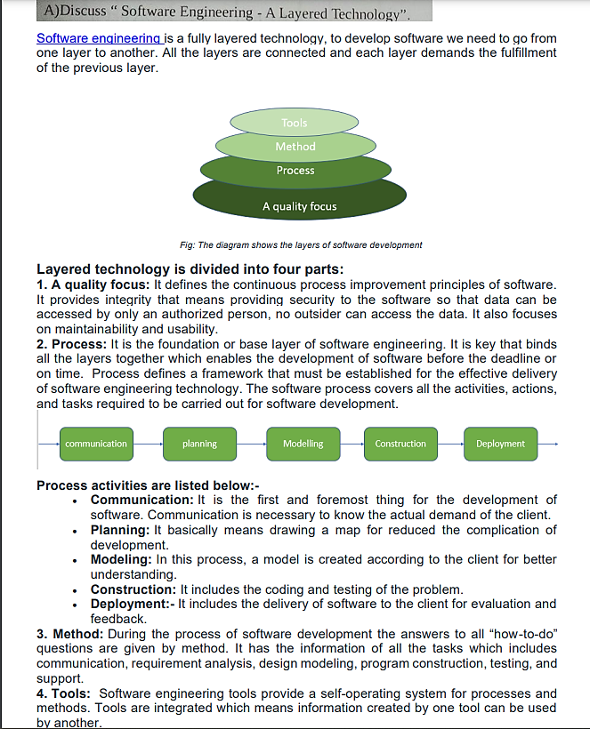

**Illustrate unified process model for software development with neat diagram.**

Unified process (UP) is an architecture centric, use case driven, iterative and incremental development process.

UP is also referred to as the unified [software development process](https://theteche.com/specialized-process-model-in-software-engineering/).

The Unified Process is an attempt to draw on the best features and characteristics of traditional software process models

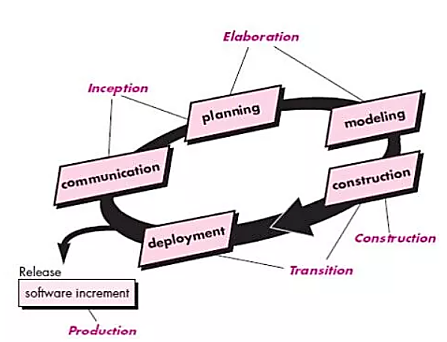

This process divides the development process into five phases:

* Inception
* Elaboration
* Conception
* Transition
* Production

The **inception phase** of the UP encompasses both customer communication and planning activities. By collaborating with stakeholders, business requirements for the software are identified; a rough architecture for the system is proposed; and a plan for the iterative, incremental nature of the ensuing project is developed.

The **elaboration phase** encompasses the planning and modeling activities of the generic process model. Elaboration refines and expands the preliminary use cases that were developed as part of the inception phase.

The **construction phase** of the UP is identical to the construction activity defined for the generic software process. The construction phase develops the software components that will make each use case operational for end users. All necessary and required features and functions for the software increment (the release) are then implemented in source code.

The **transition phase** of the UP encompasses the latter stages of the generic construction activity and the first part of the generic deployment (delivery and feedback) activity. Software is given to end users for beta testing and user feedback reports both defects and necessary changes. At the conclusion of the transition phase, the software increment becomes a usable software release.

The **production phase** of the UP coincides with the deployment activity of the generic process. During this phase, the ongoing use of the software is monitored, support for the operating environment (infrastructure) is provided, and defect reports and requests for changes are submitted and evaluated.

**Compare Waterfall Model with RAD Model.**

|  |  |  |
| --- | --- | --- |
| S. | Waterfall Model | RAD Model |
| 1. | Waterfall model known as Classical/Traditional Model. | RAD stands for Rapid Application Development. |
| 2. | Planning is required in early stage. | There is no such constraint in RAD model. |
| 3. | High assurance is what it aims for. | Its objective is rapid development. |
| 4. | There is high amount risk in waterfall model. | There is low amount risk in RAD model. |
| 5. | In waterfall model large team size is required. | In RAD model small team size is required. |
| 6. | Waterfall model can’t handle large project. | RAD model also can’t handle large project but usually it is preferred between large and small project. |
| 7. | Any changes can be made in waterfall model only at the beginning. | Any changes can be made in RAD model anytime. |
| 8. | The product of Waterfall model is delivered after the completion of all stages. | The product of RAD model is delivered as soon as possible. |
| 9. | There is long waiting time for running software in waterfall model. | There is less waiting time for running software in RAD model, as its first version is released as soon as possible. |
| 10. | It is not flexible to changes. | It is flexible to changes. |

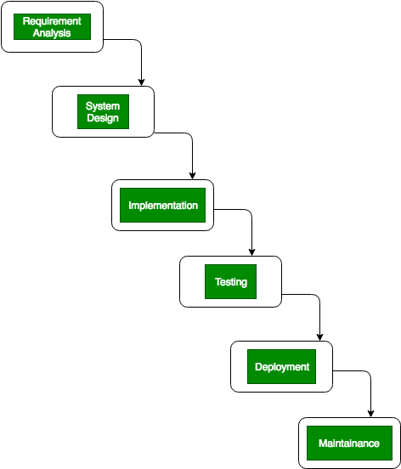

**[Waterfall Model](https://www.geeksforgeeks.org/software-engineering-classical-waterfall-model/):**   
Waterfall Model is also known as the Classical or Traditional Model. Sometimes It is referred to as the linear-sequential life cycle model because all phases involved in this model are completed one by one linearly. In this model, we get software after the completion of all coding phases. This model is used for small projects. There exist only one cycle in the waterfall model.

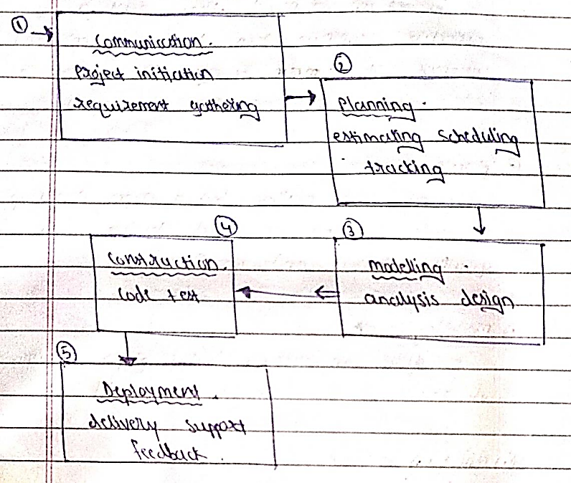

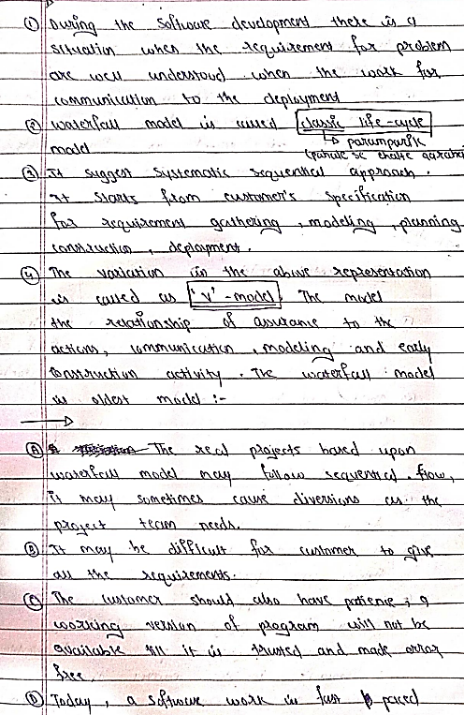

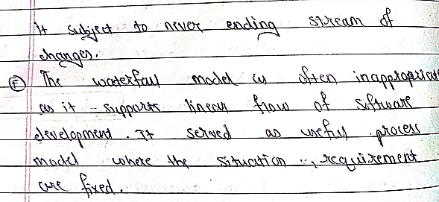

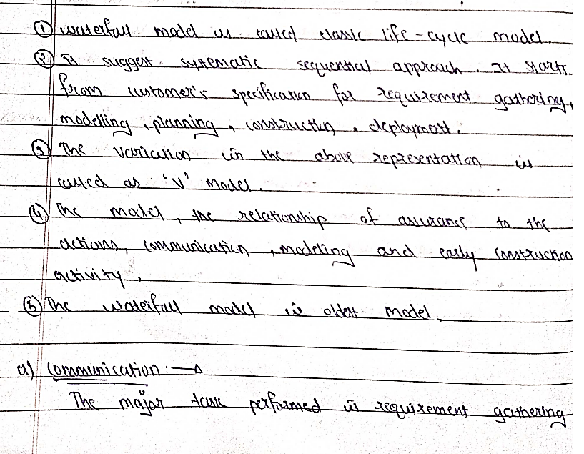

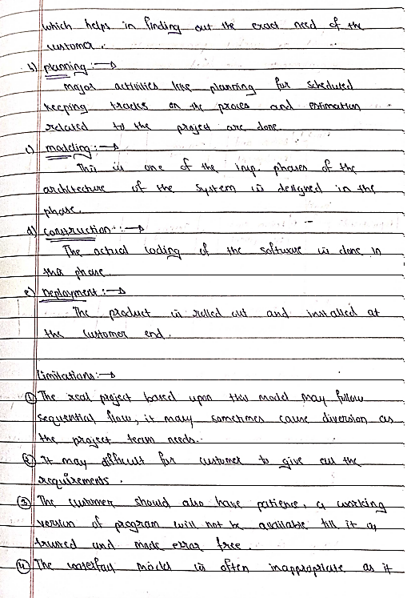

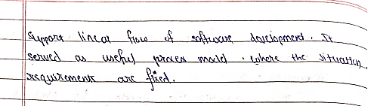

[**RAD Model**](https://www.geeksforgeeks.org/software-engineering-rapid-application-development-model-rad/)**:**   
RAD model stands for Rapid Application Development and it is the type of [Incremental Model](https://www.geeksforgeeks.org/software-engineering-incremental-process-model/). It can’t handle large projects but it can handle small projects as well as medium projects. In the RAD model, any changes can be made at any stage but in the waterfall, it can’t happen.

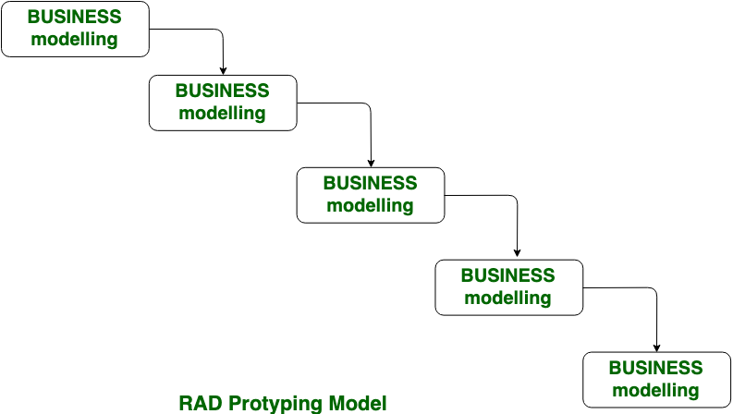

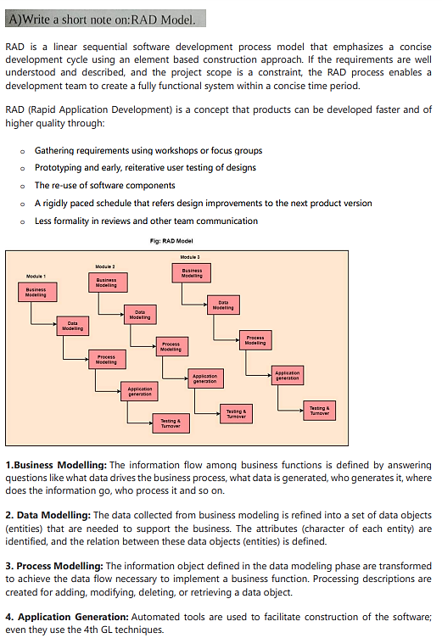

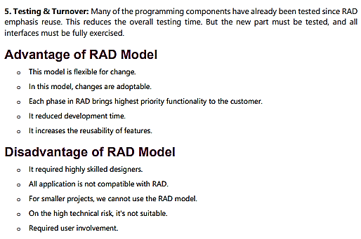

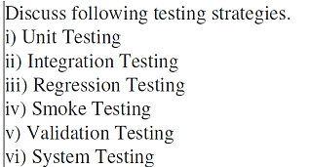

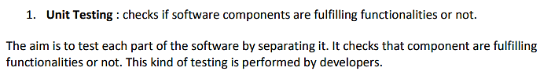

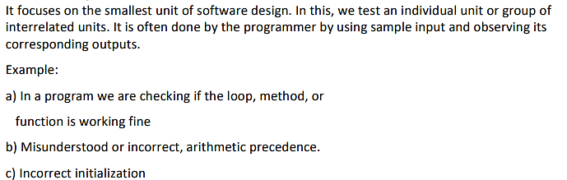



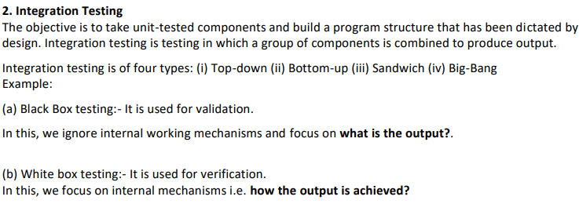

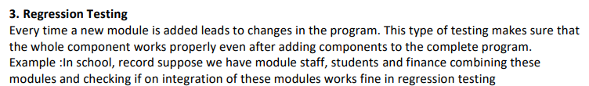

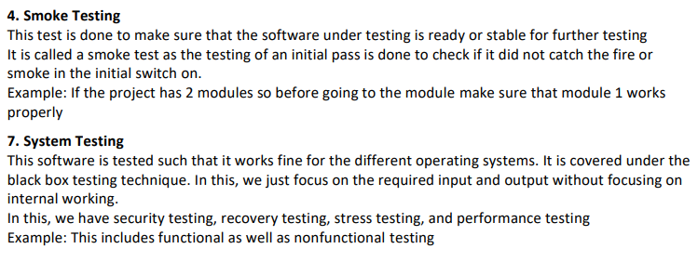



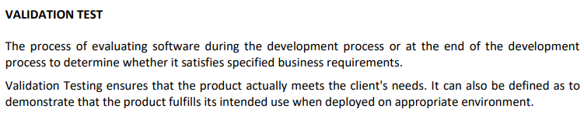

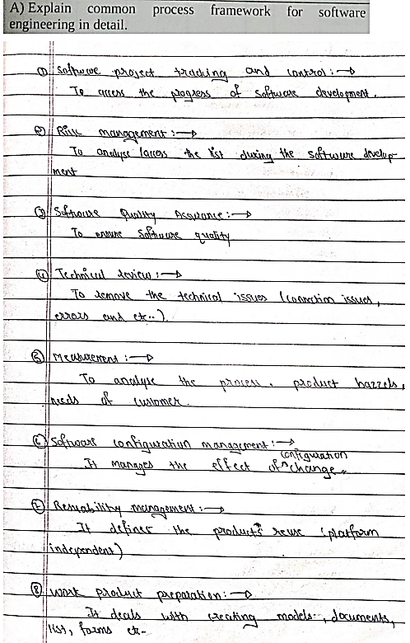

**Software Process Framework** is an abstraction of the software development process. Task sets, umbrella activities, and process framework activities all define the characteristics of the software development process.

Software process includes:

* Tasks – focus on a small, specific objective.
* Action – set of tasks that produce a major work product.
* Activities – group of related tasks and actions for a major objective.

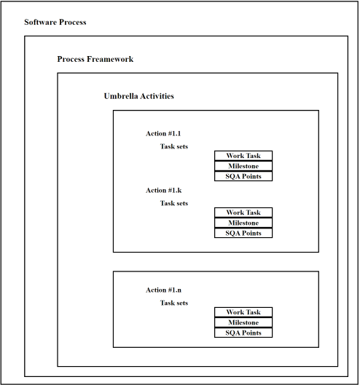

**Process Framework Activities:**

The process framework is required for representing common process activities. Five framework activities are described in a process framework for software engineering. Communication, planning, modeling, construction, and deployment are all examples of framework activities. Each engineering action defined by a framework activity comprises a list of needed work outputs, project milestones, and software quality assurance (SQA) points.

* **Communication:** By communication, customer requirement gathering is done. Communication with consumers and stakeholders to determine the system’s objectives and the software’s requirements.
* **Planning:** Establish engineering work plan, describes technical risk, lists resources requirements, work produced and defines work schedule.
* **Modeling:**

Architectural models and design to better understand the problem and for work towards the best solution. The software model is prepared by:  
       o Analysis of requirements  
       o Design

* **Construction:** Creating code, testing the system, fixing bugs, and confirming that all criteria are met. The software design is mapped into a code by:  
         o Code generation  
         o Testing
* **Deployment:** In this activity, a complete or non-complete product or software is represented to the customers to evaluate and give feedback. On the basis of their feedback, we modify the product for the supply of better products.

**Umbrella activities:**

Umbrella Activities are that take place during a software development process for improved project management and tracking.

1. **Software project tracking and control:**This is an activity in which the team can assess progress and take corrective action to maintain the schedule. Take action to keep the project on time by comparing the project’s progress against the plan.
2. **Risk management:**The risks that may affect project outcomes or quality can be analyzed. Analyze potential risks that may have an impact on the software product’s quality and outcome.
3. **Software quality assurance:** These are activities required to maintain software quality. Perform actions to ensure the product’s quality.
4. **Formal technical reviews:**It is required to assess engineering work products to uncover and remove errors before they propagate to the next activity. At each level of the process, errors are evaluated and fixed.
5. **Software configuration management:**Managing of configuration process when any change in the software occurs.
6. **Work product preparation and production:** The activities to create models, documents, logs, forms, and lists are carried out.
7. **Reusability management:**It defines criteria for work product reuse. Reusable work items should be backed up, and reusable software components should be achieved.
8. **Measurement:** In this activity, the process can be defined and collected. Also, project and product measures are used to assist the software team in delivering the required software.

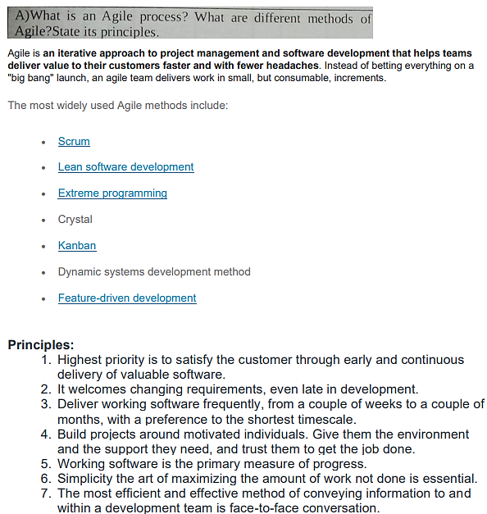

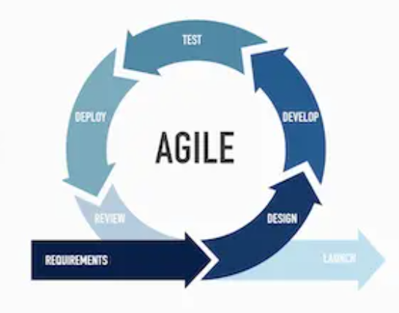

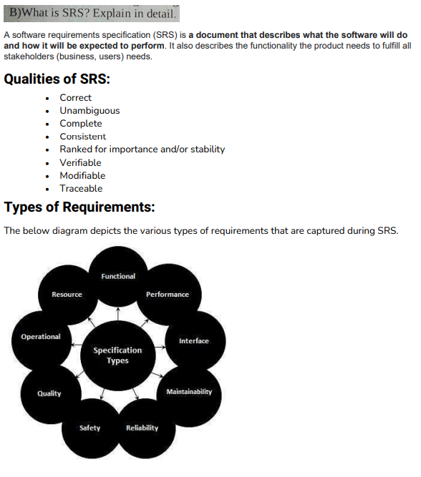

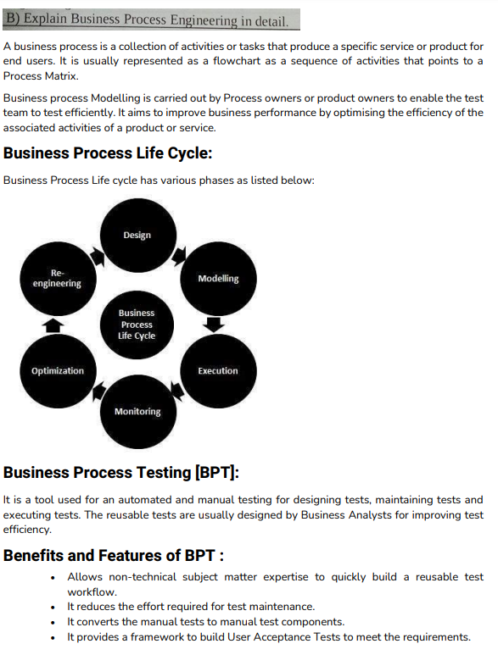

**Spiral Model :**

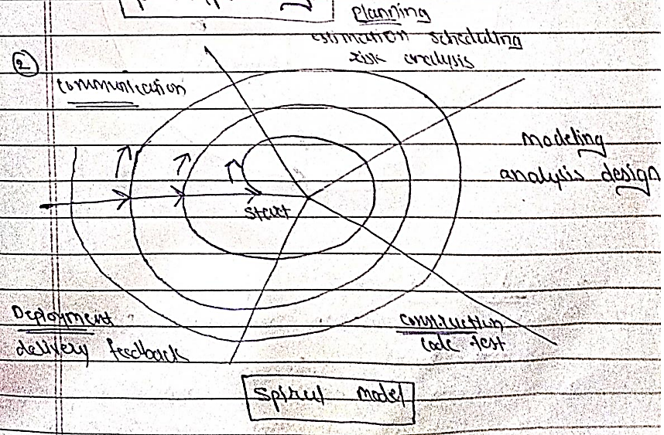

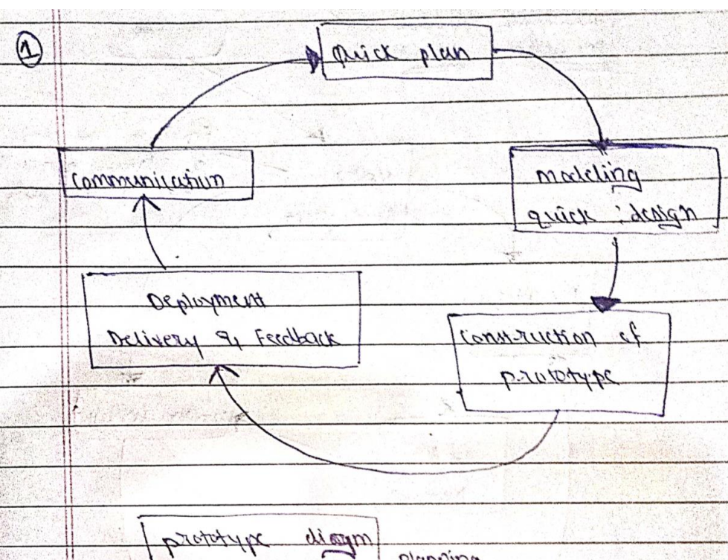

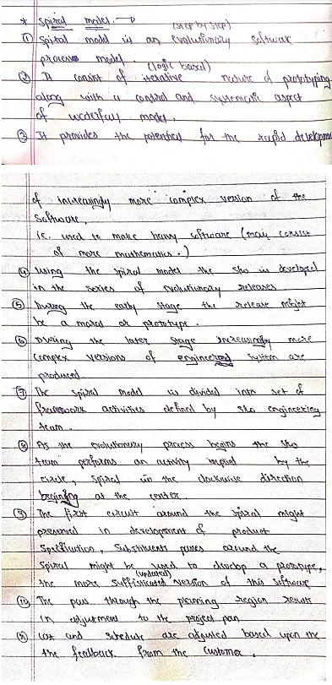

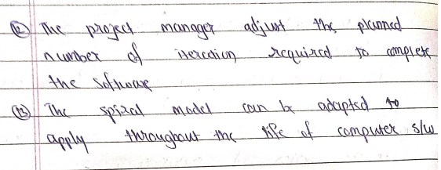

**Advantages of Spiral Model**:   
Below are some advantages of the Spiral Model.

1. **Risk Handling:** The projects with many unknown risks that occur as the development proceeds, in that case, Spiral Model is the best development model to follow due to the risk analysis and risk handling at every phase.
2. **Good for large projects:** It is recommended to use the Spiral Model in large and complex projects.
3. **Flexibility in Requirements:** Change requests in the Requirements at later phase can be incorporated accurately by using this model.
4. **Customer Satisfaction:** Customer can see the development of the product at the early phase of the software development and thus, they habituated with the system by using it before completion of the total product.

**Disadvantages of Spiral Model**:   
Below are some main disadvantages of the spiral model.

1. **Complex:** The Spiral Model is much more complex than other SDLC models.
2. **Expensive:** Spiral Model is not suitable for small projects as it is expensive.
3. **Too much dependability on Risk Analysis:** The successful completion of the project is very much dependent on Risk Analysis. Without very highly experienced experts, it is going to be a failure to develop a project using this model.
4. **Difficulty in time management:** As the number of phases is unknown at the start of the project, so time estimation is very difficult.

**Spiral model** is one of the most important Software Development Life Cycle models, which provides support for **Risk Handling**. In its diagrammatic representation, it looks like a spiral with many loops. The exact number of loops of the spiral is unknown and can vary from project to project. Each loop of the spiral is called a **Phase of the software development process.** The exact number of phases needed to develop the product can be varied by the project manager depending upon the project risks.

## **When to use Spiral Model?**

* When deliverance is required to be frequent.
* When the project is large
* When requirements are unclear and complex
* When changes may require at any time
* Large and high budget projects

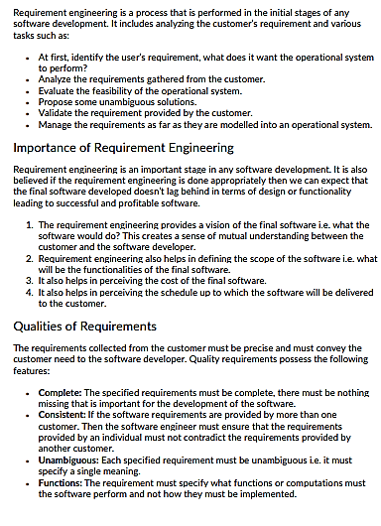

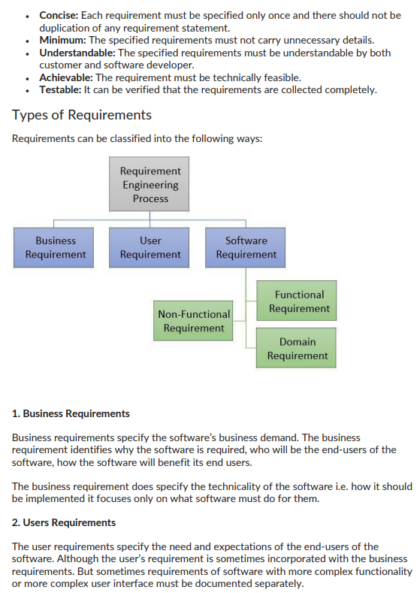

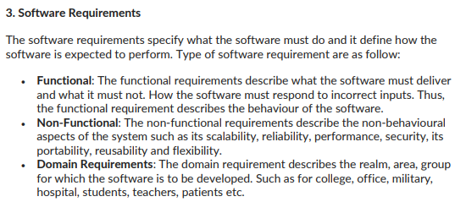

Process:

## **Requirement Engineering Process**

It is a four-step process, which includes -

1. Feasibility Study
2. Requirement Elicitation and Analysis
3. Software Requirement Specification
4. Software Requirement Validation
5. Software Requirement Management

### 1. Feasibility Study:

The objective behind the feasibility study is to create the reasons for developing the software that is acceptable to users, flexible to change and conformable to established standards.

**Types of Feasibility:**

**Technical Feasibility** - Technical feasibility evaluates the current technologies, which are needed to accomplish customer requirements within the time and budget.

1. **Operational Feasibility** - Operational feasibility assesses the range in which the required software performs a series of levels to solve business problems and customer requirements.
2. **Economic Feasibility** - Economic feasibility decides whether the necessary software can generate financial profits for an organization.

### 2. Requirement Elicitation and Analysis:

This is also known as the **gathering of requirements**. Here, requirements are identified with the help of customers and existing systems processes, if available.

Analysis of requirements starts with requirement elicitation. The requirements are analyzed to identify inconsistencies, defects, omission, etc. We describe requirements in terms of relationships and also resolve conflicts if any.

**Problems of Elicitation and Analysis**

* Getting all, and only, the right people involved.
* Stakeholders often don't know what they want
* Stakeholders express requirements in their terms.
* Stakeholders may have conflicting requirements.
* Requirement change during the analysis process.
* Organizational and political factors may influence system requirements.

### 3. Software Requirement Specification:

Software requirement specification is a kind of document which is created by a software analyst after the requirements collected from the various sources - the requirement received by the customer written in ordinary language. It is the job of the analyst to write the requirement in technical language so that they can be understood and beneficial by the development team.

The models used at this stage include ER diagrams, data flow diagrams (DFDs), function decomposition diagrams (FDDs), data dictionaries, etc.

* **Data Flow Diagrams:** Data Flow Diagrams (DFDs) are used widely for modeling the requirements. DFD shows the flow of data through a system. The system may be a company, an organization, a set of procedures, a computer hardware system, a software system, or any combination of the preceding. The DFD is also known as a data flow graph or bubble chart.
* **Data Dictionaries:** Data Dictionaries are simply repositories to store information about all data items defined in DFDs. At the requirements stage, the data dictionary should at least define customer data items, to ensure that the customer and developers use the same definition and terminologies.
* **Entity-Relationship Diagrams:** Another tool for requirement specification is the entity-relationship diagram, often called an "**E-R diagram**." It is a detailed logical representation of the data for the organization and uses three main constructs i.e. data entities, relationships, and their associated attributes.

### 4. Software Requirement Validation:

After requirement specifications developed, the requirements discussed in this document are validated. The user might demand illegal, impossible solution or experts may misinterpret the needs. Requirements can be the check against the following conditions -

* If they can practically implement
* If they are correct and as per the functionality and specially of software
* If there are any ambiguities
* If they are full
* If they can describe

**Requirements Validation Techniques**

* **Requirements reviews/inspections:** systematic manual analysis of the requirements.
* **Prototyping:** Using an executable model of the system to check requirements.
* **Test-case generation:** Developing tests for requirements to check testability.
* **Automated consistency analysis:** checking for the consistency of structured requirements descriptions.

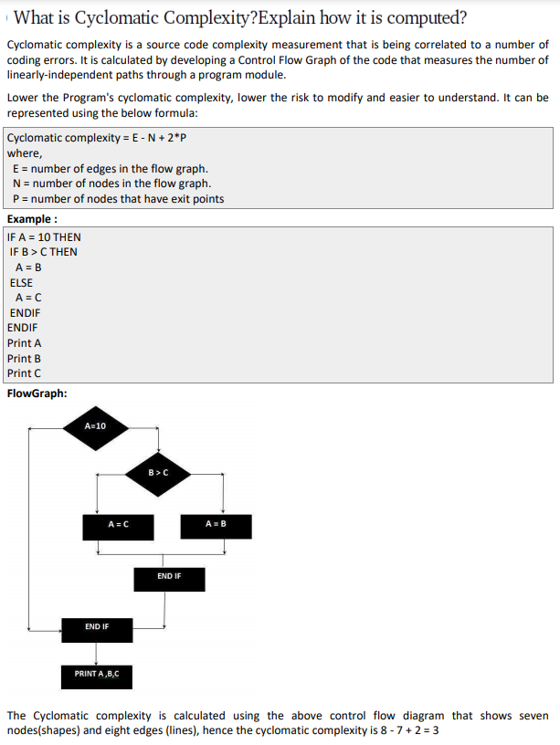

[Cyclomatic complexity (CYC) is a software metric used to determine the complexity of a program. It is a count of the number of decisions in the source code. The higher the count, the more complex the code.](https://www.perforce.com/video-tutorials/qac/cyclomatic-complexity-explained)

It is computed using the Control Flow Graph of the program.

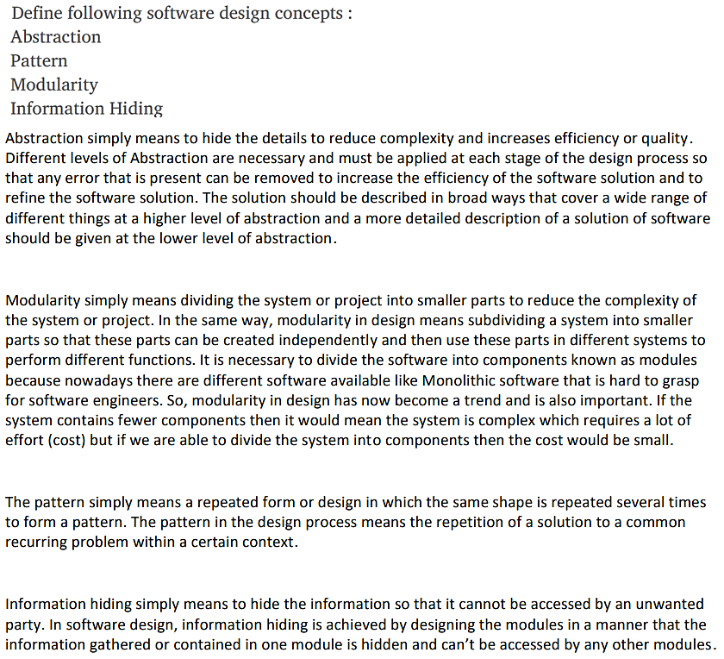

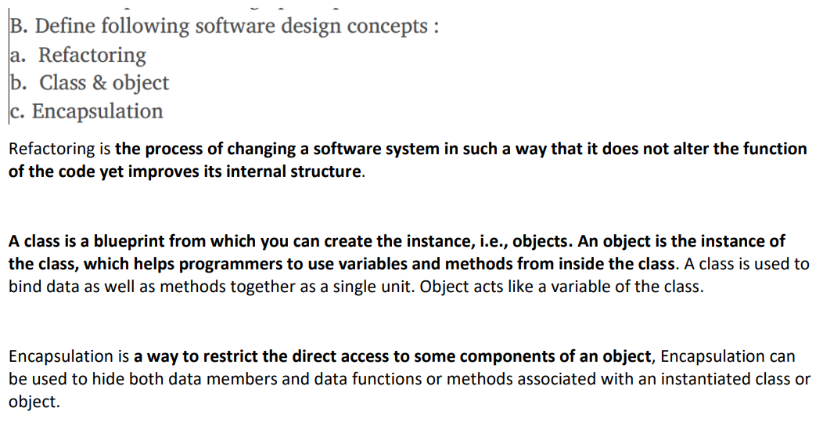

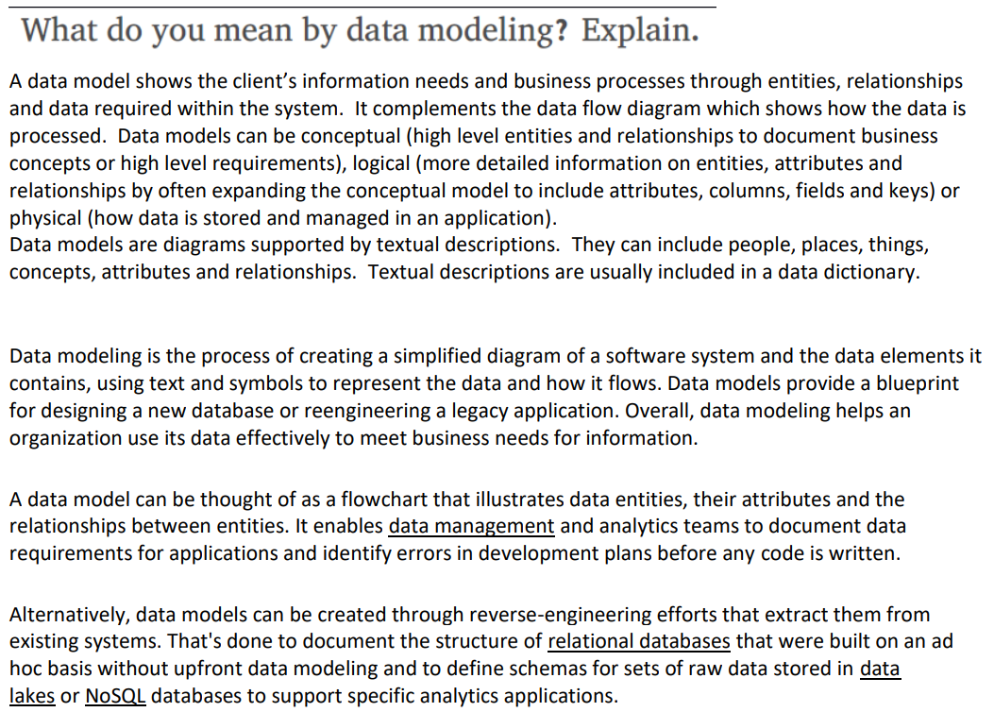

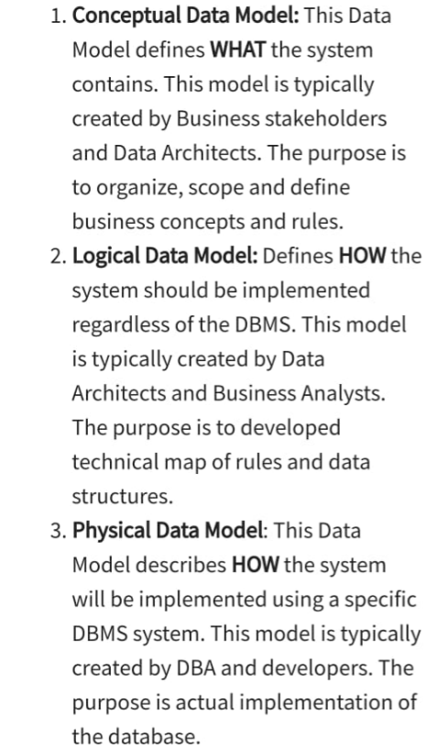

Different types of data models are:

Hierarchy dm

Er model

Relational dm

dimensional dm

network dm

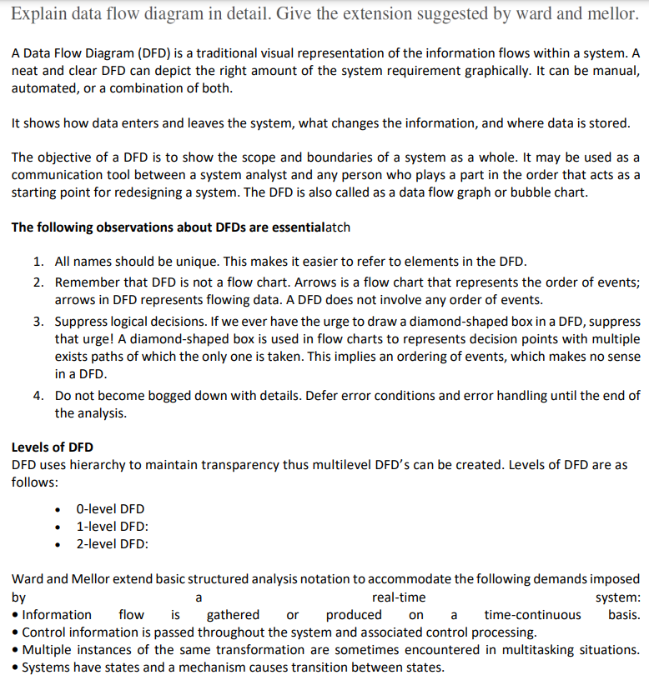

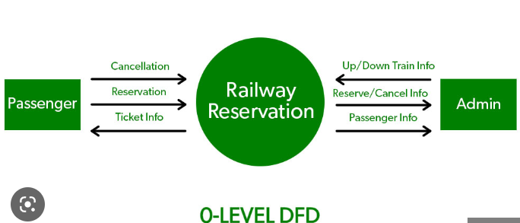

# **Incremental Model**

Incremental Model is a process of software development where requirements divided into multiple standalone modules of the software development cycle. In this model, each module goes through the requirements, design, implementation and testing phases. Every subsequent release of the module adds function to the previous release. The process continues until the complete system achieved.

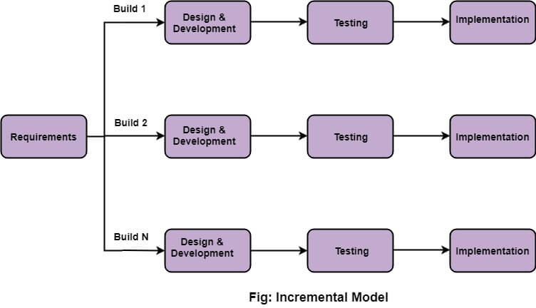

## **The various phases of incremental model are as follows:**

**1. Requirement analysis:** In the first phase of the incremental model, the product analysis expertise identifies the requirements. And the system functional requirements are understood by the requirement analysis team. To develop the software under the incremental model, this phase performs a crucial role.

**2. Design & Development:** In this phase of the Incremental model of SDLC, the design of the system functionality and the development method are finished with success. When software develops new practicality, the incremental model uses style and development phase.

**3. Testing:** In the incremental model, the testing phase checks the performance of each existing function as well as additional functionality. In the testing phase, the various methods are used to test the behavior of each task.

**4. Implementation:** Implementation phase enables the coding phase of the development system. It involves the final coding that design in the designing and development phase and tests the functionality in the testing phase. After completion of this phase, the number of the product working is enhanced and upgraded up to the final system product

## **When we use the Incremental Model?**

* When the requirements are superior.
* A project has a lengthy development schedule.
* When Software team are not very well skilled or trained.
* When the customer demands a quick release of the product.
* You can develop prioritized requirements first.

## **Advantage of Incremental Model**

* Errors are easy to be recognized.
* Easier to test and debug
* More flexible.
* Simple to manage risk because it handled during its iteration.
* The Client gets important functionality early.

## **Disadvantage of Incremental Model**

* Need for good planning
* Total Cost is high.
* Well defined module interfaces are needed.

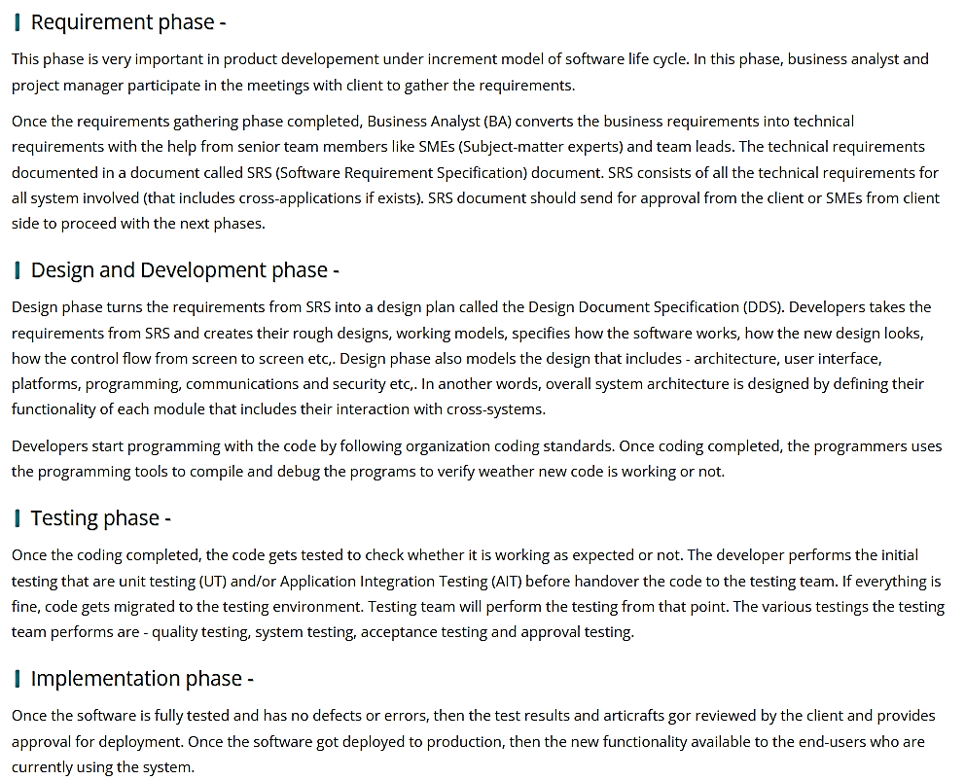

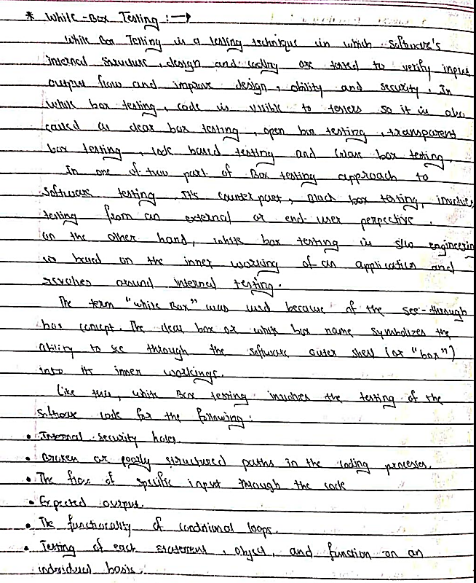

**Advantages:**

1. White box testing is very thorough as the entire code and structures are tested.
2. It results in the optimization of code removing error and helps in removing extra lines of code.
3. It can start at an earlier stage as it doesn’t require any interface as in case of black box testing.
4. Easy to automate.
5. White box testing can be easily started in Software Development Life Cycle.
6. Easy Code Optimization.

**Disadvantages:**

1. Main disadvantage is that it is very expensive.
2. Redesign of code and rewriting code needs test cases to be written again.
3. Testers are required to have in-depth knowledge of the code and programming language as opposed to black box testing.
4. Missing functionalities cannot be detected as the code that exists is tested.
5. Very complex and at times not realistic.
6. Much more chances of Errors in production.

**Differences between Black Box Testing vs White Box Testing:**

|  |  |  |
| --- | --- | --- |
| S. No. | Black Box Testing | White Box Testing |
| 1. | It is a way of software testing in which the internal structure or the program or the code is hidden and nothing is known about it. | It is a way of testing the software in which the tester has knowledge about the internal structure or the code or the program of the software. |
| 2. | Implementation of code is not needed for black box testing. | Code implementation is necessary for white box testing. |
| 3. | It is mostly done by software testers. | It is mostly done by software developers. |
| 4. | No knowledge of implementation is needed. | Knowledge of implementation is required. |
| 5. | It can be referred to as outer or external software testing. | It is the inner or the internal software testing. |
| 6. | It is a functional test of the software. | It is a structural test of the software. |
| 7. | This testing can be initiated based on the requirement specifications document. | This type of testing of software is started after a detail design document. |
| 8. | No knowledge of programming is required. | It is mandatory to have knowledge of programming. |
| 9. | It is the behavior testing of the software. | It is the logic testing of the software. |
| 10. | It is applicable to the higher levels of testing of software. | It is generally applicable to the lower levels of software testing. |
| 11. | It is also called closed testing. | It is also called as clear box testing. |
| 12. | It is least time consuming. | It is most time consuming. |
| 13. | It is not suitable or preferred for algorithm testing. | It is suitable for algorithm testing. |
| 14. | Can be done by trial and error ways and methods. | Data domains along with inner or internal boundaries can be better tested. |
| 15. | **Example:** Search something on google by using keywords | **Example:** By input to check and verify loops |
| 16. | **Black-box test design techniques-**   * Decision table testing * All-pairs testing * Equivalence partitioning * Error guessing | **White-box test design techniques-**   * Control flow testing * Data flow testing * Branch testing |
| 17. | **Types of Black Box Testing:**   * Functional Testing * Non-functional testing * Regression Testing | **Types of White Box Testing:**   * Path Testing * Loop Testing * Condition testing |
| 18. | It is less exhaustive as compared to white box testing. | It is comparatively more exhaustive than black box testing. |

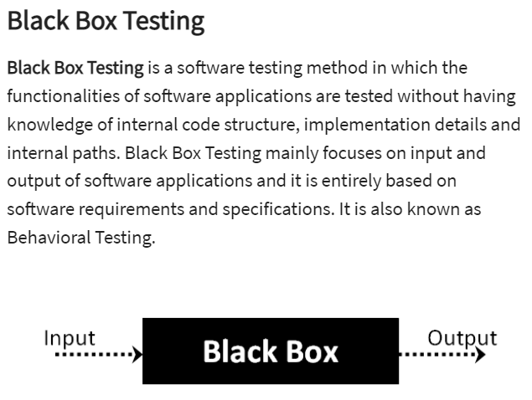

**Advantages of Black Box Testing:**

* The tester does not need to have more functional knowledge or programming skills to implement the Black Box Testing.
* It is efficient for implementing the tests in the larger system.
* Tests are executed from the user’s or client’s point of view.
* Test cases are easily reproducible.
* It is used in finding the ambiguity and contradictions in the functional specifications.

**Disadvantages of Black Box Testing:**

* There is a possibility of repeating the same tests while implementing the testing process.
* Without clear functional specifications, test cases are difficult to implement.
* It is difficult to execute the test cases because of complex inputs at different stages of testing.
* Sometimes, the reason for the test failure cannot be detected.
* Some programs in the application are not tested.
* It does not reveal the errors in the control structure.
* Working with a large sample space of inputs can be exhaustive and consumes a lot of time.

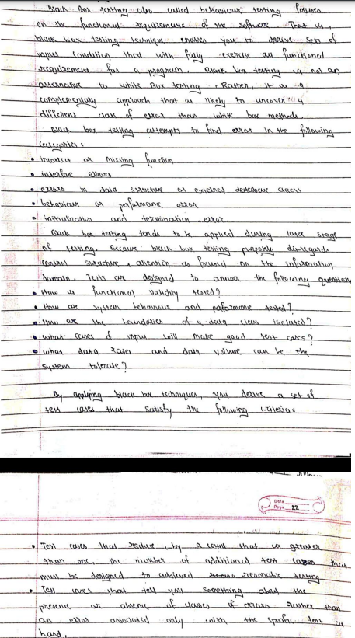

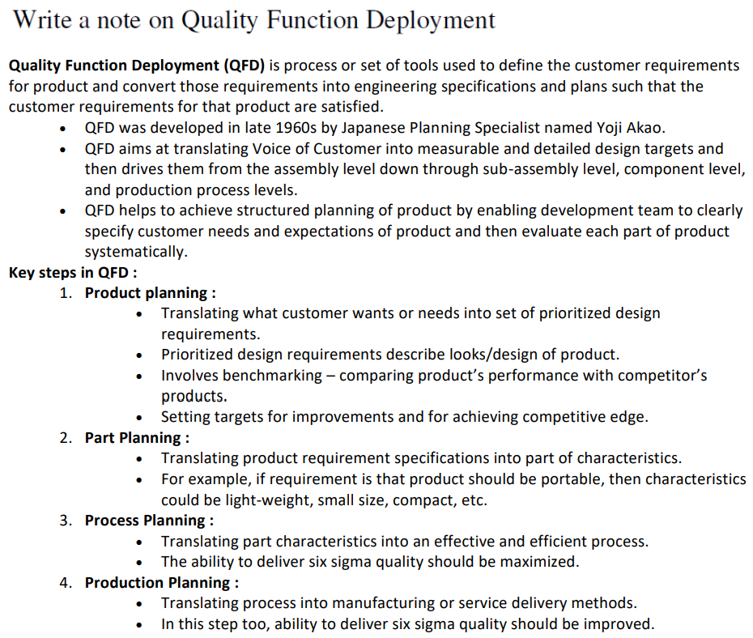

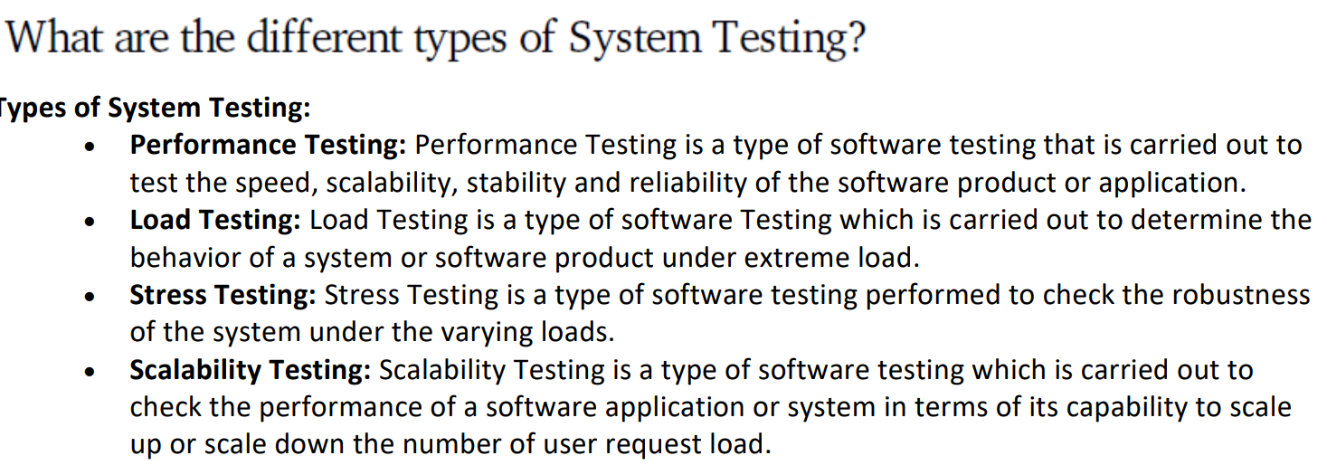

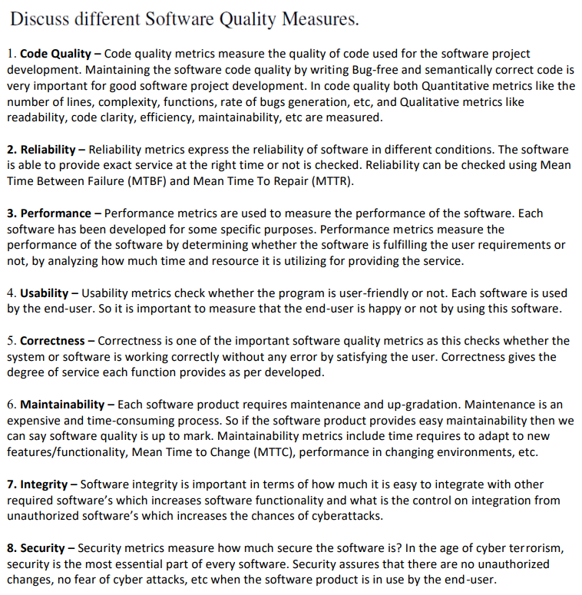

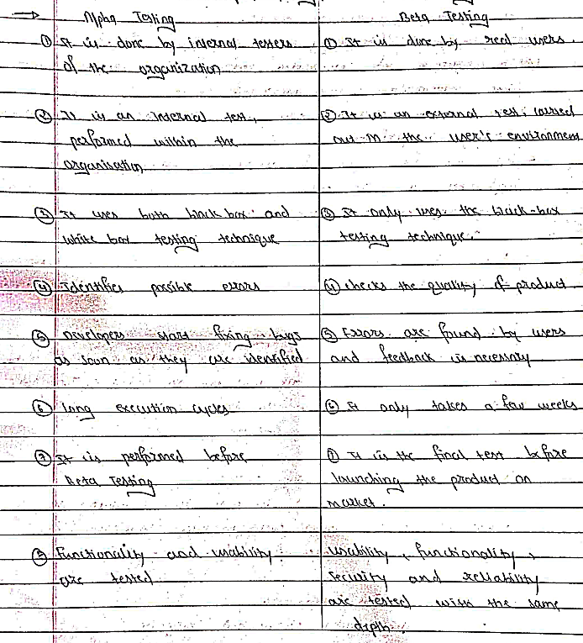

|  |  |
| --- | --- |
| **Verification** | **Validation** |
| It includes checking documents, design, codes and programs. | It includes testing and validating the actual product. |
| Verification is the static testing. | Validation is the dynamic testing. |
| It does *not* include the execution of the code. | It includes the execution of the code. |
| Methods used in verification are reviews, walkthroughs, inspections and desk-checking. | Methods used in validation are Black Box Testing, White Box Testing and non-functional testing. |
| It checks whether the software conforms to specifications or not. | It checks whether the software meets the requirements and expectations of a customer or not. |
| It can find the bugs in the early stage of the development. | It can only find the bugs that could not be found by the verification process. |
| The goal of verification is application and software architecture and specification. | The goal of validation is an actual product. |
| Quality assurance team does verification. | Validation is executed on software code with the help of testing team. |
| It comes before validation. | It comes after verification. |
| It consists of checking of documents/files and is performed by human. | It consists of execution of program and is performed by computer. |
|  |  |

|  |  |
| --- | --- |
| Testing | Debugging |
| Testing is the process to find bugs and errors. | Debugging is the process to correct the bugs found during testing. |
| It is the process to identify the failure of implemented code. | It is the process to give the absolution to code failure. |
| Testing is the display of errors. | Debugging is a deductive process. |
| Testing is done by the tester. | Debugging is done by either programmer or developer. |
| There is no need of design knowledge in the testing process. | Debugging can’t be done without proper design knowledge. |
| Testing can be done by insider as well as outsider. | Debugging is done only by insider. Outsider can’t do debugging. |
| Testing can be manual or automated. | Debugging is always manual. Debugging can’t be automated. |
| It is based on different testing levels i.e. unit testing, integration testing, system testing etc. | Debugging is based on different types of bugs. |
| Testing is a stage of software development life cycle (SDLC). | Debugging is not an aspect of software development life cycle, it occurs as a consequence of testing. |
| Testing is composed of validation and verification of software. | While debugging process seeks to match symptom with cause, by that it leads to the error correction. |
| Testing is initiated after the code is written. | Debugging commences with the execution of a test case. |
| Testing process based on various levels of testing-system testing, integration testing, unit testing, etc. | Debugging process based on various types of bugs is present in a system. |
| Software testing contains various type of testing methods, which are as follow:   * Black-box testing * White-box testing * Grey-box testing   And some other type of testing types is as below:   * Unit testing * Integration Testing * System Testing * Stress Testing * Performance Testing * Compatibility Testing * Beta Testing * Alpha Testing * Smoke Testing * Regression Testing * User Acceptance Testing and so on. | Debugging involves a various type of approaches, which are as follows:   * Induction * Brute Force * Deduction |

\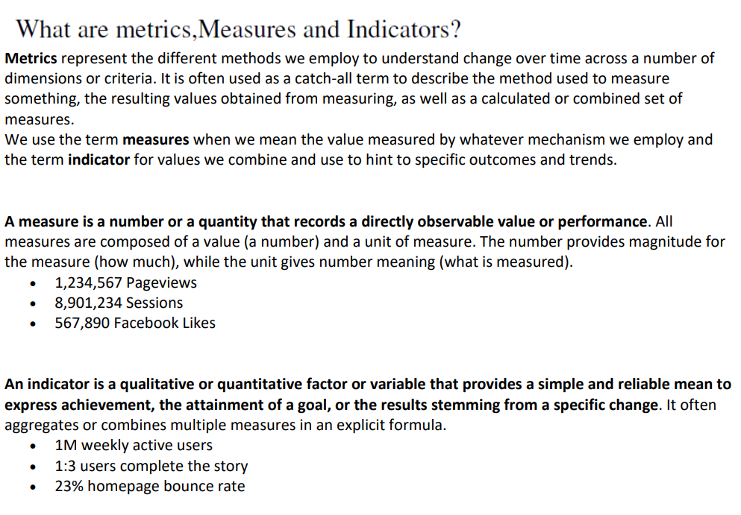

# **Entity-Relationship Diagrams**

ER-modeling is a data modeling method used in software engineering to produce a conceptual data model of an information system. Diagrams created using this ER-modeling method are called Entity-Relationship Diagrams or ER diagrams or ERDs.

## **Purpose of ERD**

* The database analyst gains a better understanding of the data to be contained in the database through the step of constructing the ERD.
* The ERD serves as a documentation tool.
* Finally, the ERD is used to connect the logical structure of the database to users. In particular, the ERD effectively communicates the logic of the database to users.

## **Components of an ER Diagrams**

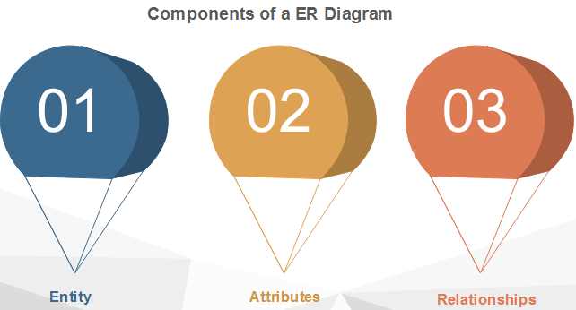

### 1. Entity

An entity can be a real-world object, either animate or inanimate, that can be merely identifiable. An entity is denoted as a rectangle in an ER diagram. For example, in a school database, students, teachers, classes, and courses offered can be treated as entities. All these entities have some attributes or properties that give them their identity.

**Entity Set**

An entity set is a collection of related types of entities. An entity set may include entities with attribute sharing similar values. For example, a Student set may contain all the students of a school; likewise, a Teacher set may include all the teachers of a school from all faculties. Entity set need not be disjoint.

Entities are denoted utilizing their properties, known as attributes. All attributes have values. For example, a student entity may have name, class, and age as attributes.

There exists a domain or range of values that can be assigned to attributes. For example, a student's name cannot be a numeric value. It has to be alphabetic. A student's age cannot be negative, etc.

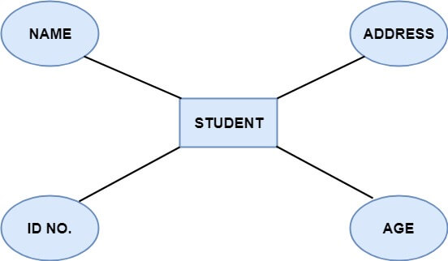

**There are four types of Attributes:**

1. Key attribute
2. Composite attribute
3. Single-valued attribute
4. Multi-valued attribute
5. Derived attribute

**1. Key attribute:** Key is an attribute or collection of attributes that uniquely identifies an entity among the entity set. For example, the roll_number of a student makes him identifiable among students.

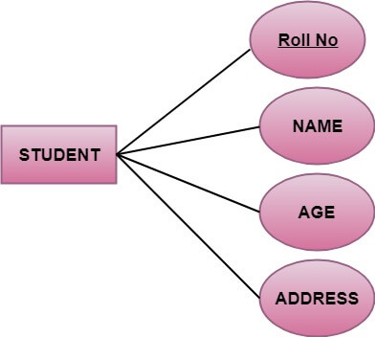

**There are mainly three types of keys:**

1. **Super key:** A set of attributes that collectively identifies an entity in the entity set.
2. **Candidate key:** A minimal super key is known as a candidate key. An entity set may have more than one candidate key.
3. **Primary key:** A primary key is one of the candidate keys chosen by the database designer to uniquely identify the entity set.

**2. Composite attribute:** An attribute that is a combination of other attributes is called a composite attribute. For example, In student entity, the student address is a composite attribute as an address is composed of other characteristics such as pin code, state, country.

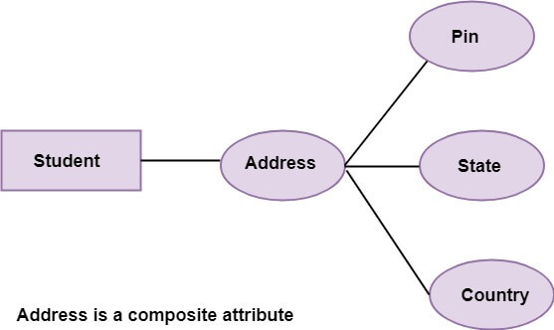

**3. Single-valued attribute:** Single-valued attribute contain a single value. For example, Social_Security_Number.

**4. Multi-valued Attribute:** If an attribute can have more than one value, it is known as a multi-valued attribute. Multi-valued attributes are depicted by the double ellipse. For example, a person can have more than one phone number, email-address, etc.

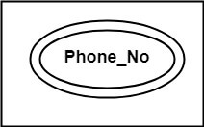

**5. Derived attribute:** Derived attributes are the attribute that does not exist in the physical database, but their values are derived from other attributes present in the database. For example, age can be derived from date_of_birth. In the ER diagram, Derived attributes are depicted by the dashed ellipse.

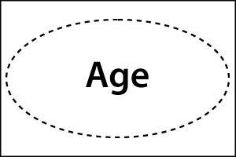  
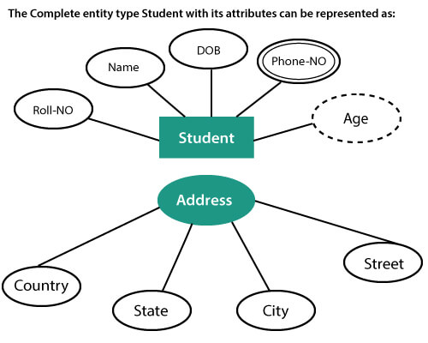

## **3. Relationships**

The association among entities is known as relationship. Relationships are represented by the diamond-shaped box. For example, an employee works_at a department, a student enrolls in a course. Here, Works_at and Enrolls are called relationships.

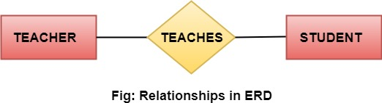

## **Relationship set**

A set of relationships of a similar type is known as a relationship set. Like entities, a relationship too can have attributes. These attributes are called descriptive attributes.

## **Degree of a relationship set**

The number of participating entities in a relationship describes the degree of the relationship. The three most common relationships in E-R models are:

1. Unary (degree1)
2. Binary (degree2)
3. Ternary (degree3)

**1. Unary relationship:** This is also called recursive relationships. It is a relationship between the instances of one entity type. For example, one person is married to only one person.

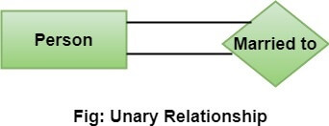

**2. Binary relationship:** It is a relationship between the instances of two entity types. For example, the Teacher teaches the subject.

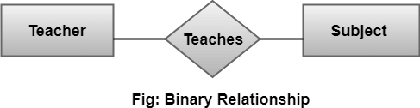

**3. Ternary relationship:** It is a relationship amongst instances of three entity types. In fig, the relationships "**may have**" provide the association of three entities, i.e., TEACHER, STUDENT, and SUBJECT. All three entities are many-to-many participants. There may be one or many participants in a ternary relationship.

In general, "**n**" entities can be related by the same relationship and is known as **n-ary** relationship.

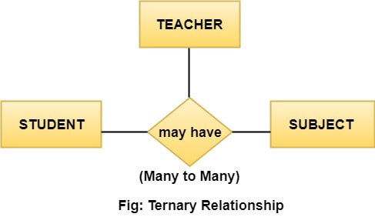

## **Cardinality**

Cardinality describes the number of entities in one entity set, which can be associated with the number of entities of other sets via relationship set.

### Types of Cardinalities

**1. One to One:** One entity from entity set A can be contained with at most one entity of entity set B and vice versa. Let us assume that each student has only one student ID, and each student ID is assigned to only one person. So, the relationship will be one to one.

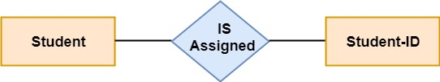

**Using Sets, it can be represented as:**

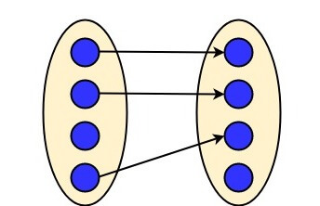

**2. One to many:** When a single instance of an entity is associated with more than one instances of another entity then it is called one to many relationships. For example, a client can place many orders; a order cannot be placed by many customers.

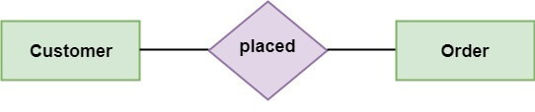

**Using Sets, it can be represented as:**

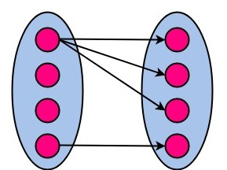

**3. Many to One:** More than one entity from entity set A can be associated with at most one entity of entity set B, however an entity from entity set B can be associated with more than one entity from entity set A. For example - many students can study in a single college, but a student cannot study in many colleges at the same time.

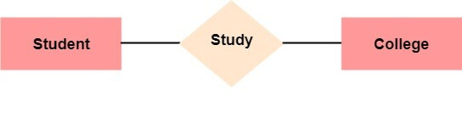

**Using Sets, it can be represented as:**

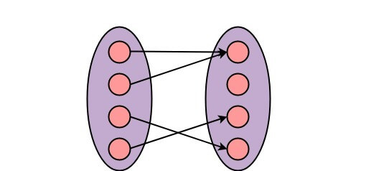

**4. Many to Many:** One entity from A can be associated with more than one entity from B and vice-versa. For example, the student can be assigned to many projects, and a project can be assigned to many students.

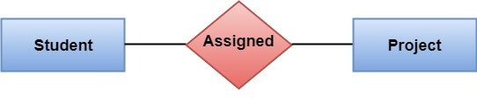

**Using Sets, it can be represented as:**

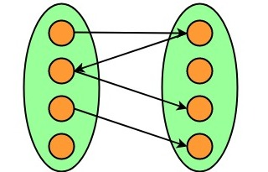

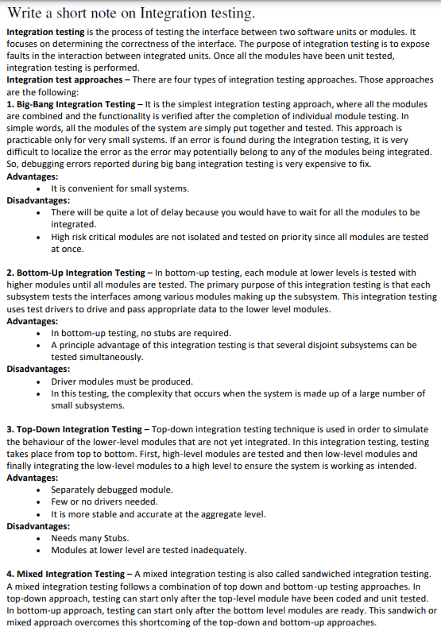

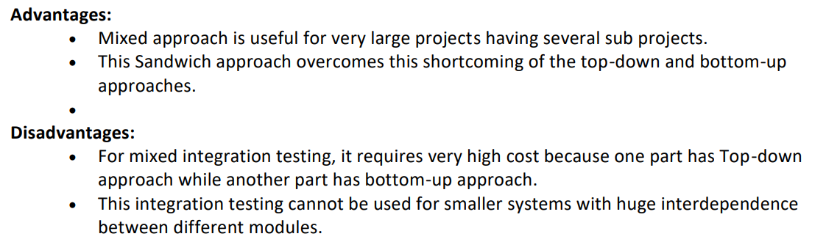



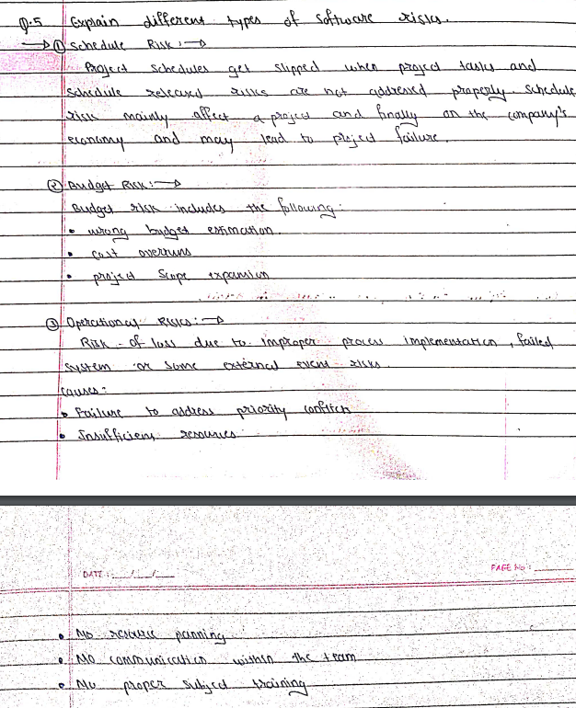

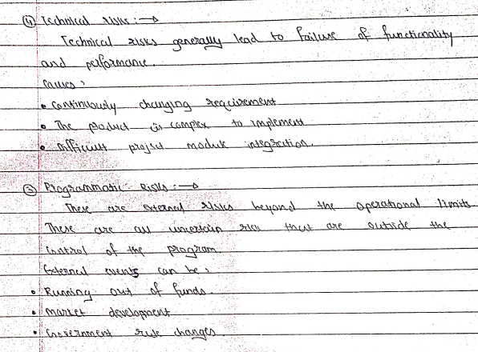

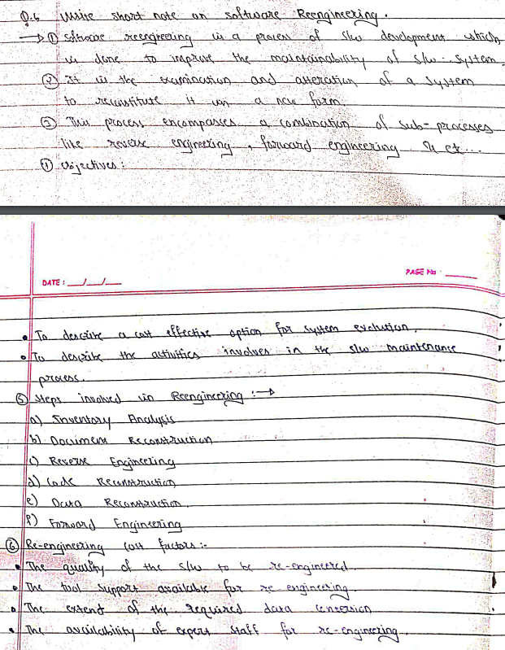

# **Project Scheduling**

Project-task scheduling is a significant project planning activity. It comprises deciding which functions would be taken up when. To schedule the project plan, a software project manager wants to do the following:

1. Identify all the functions required to complete the project.
2. Break down large functions into small activities.
3. Determine the dependency among various activities.
4. Establish the most likely size for the time duration required to complete the activities.
5. Allocate resources to activities.
6. Plan the beginning and ending dates for different activities.
7. Determine the critical path. A critical way is the group of activities that decide the duration of the project.

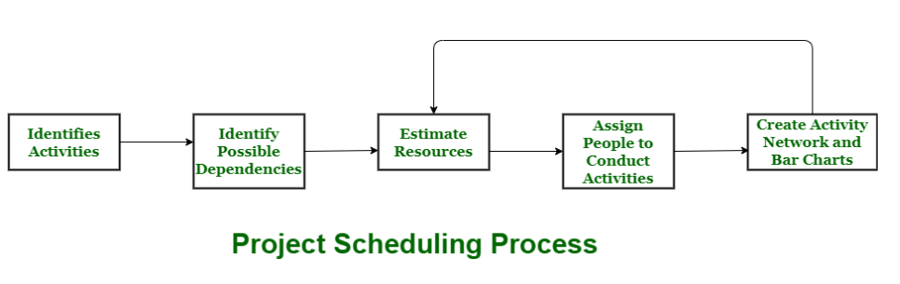

**Process :**  
The manager needs to estimate time and resources of project while scheduling project. All activities in project must be arranged in a coherent sequence that means activities should be arranged in a logical and well-organized manner for easy to understand. Initial estimates of project can be made optimistically which means estimates can be made when all favorable things will happen and no threats or problems take place.

The total work is separated or divided into various small activities or tasks during project schedule. Then, Project manager will decide time required for each activity or task to get completed. Even some activities are conducted and performed in parallel for efficient performance. The project manager should be aware of fact that each stage of project is not problem-free.

**Problems arise during Project Development Stage :**

* People may leave or remain absent during particular stage of development.
* Hardware may get failed while performing.
* Software resource that is required may not be available at present, etc.

The project schedule is represented as set of chart in which work-breakdown structure and dependencies within various activities are represented. To accomplish and complete project within a given schedule, required resources must be available when they are needed. Therefore, resource estimation should be done before starting development.

**Resources required for Development of Project :**

* Human effort
* Sufficient disk space on server
* Specialized hardware
* Software technology
* Travel allowance required by project staff, etc.

**Advantages of Project Scheduling :**  
There are several advantages provided by project schedule in our project management:

* It simply ensures that everyone remains on same page as far as tasks get completed, dependencies, and deadlines.
* It helps in identifying issues early and concerns such as lack or unavailability of resources.
* It also helps to identify relationships and to monitor process.
* It provides effective budget management and risk mitigation.

**Software Quality Assurance (SQA)** is simply a way to assure quality in the software. It is the set of activities which ensure processes, procedures as well as standards are suitable for the project and implemented correctly.

Software Quality Assurance is a process which works parallel to development of software. It focuses on improving the process of development of software so that problems can be prevented before they become a major issue. Software Quality Assurance is a kind of Umbrella activity that is applied throughout the software process.

Generally the quality of the software is verified by the third party organization like[international standard organizations](https://www.geeksforgeeks.org/iso-standards-in-software-engineering/).

**Software quality assurance focuses on:**

* software’s portability
* software’s usability
* software’s reusability
* software’s correctness
* software’s maintainability
* software’s error control

**Software Quality Assurance has:**

1. A quality management approach
2. Formal technical reviews
3. Multi testing strategy
4. Effective software engineering technology
5. Measurement and reporting mechanism

**Benefits of Software Quality Assurance (SQA):** 

1. SQA produces high quality software.
2. High quality application saves time and cost.
3. SQA is beneficial for better reliability.
4. SQA is beneficial in the condition of no maintenance for a long time.
5. High quality commercial software increase market share of company.
6. Improving the process of creating software.
7. Improves the quality of the software.

**Disadvantage of SQA:**   
There are a number of disadvantages of quality assurance. Some of them include adding more resources, employing more workers to help maintain quality and so much more.

[RMMM Plan :](https://www.geeksforgeeks.org/short-note-on-risk-assessment-and-risk-mitigation/)   
A risk management technique is usually seen in the software Project plan. This can be divided into Risk Mitigation, Monitoring, and Management Plan (RMMM). In this plan, all works are done as part of risk analysis. As part of the overall project plan project manager generally uses this RMMM plan.

In some software teams, risk is documented with the help of a Risk Information Sheet (RIS). This RIS is controlled by using a database system for easier management of information i.e creation, priority ordering, searching, and other analysis. After documentation of RMMM and start of a project, risk mitigation and monitoring steps will start.

**Risk Mitigation :**   
It is an activity used to avoid problems (Risk Avoidance).   
Steps for mitigating the risks as follows.

1. Finding out the risk.
2. Removing causes that are the reason for risk creation.
3. Controlling the corresponding documents from time to time.
4. Conducting timely reviews to speed up the work.

**Risk Monitoring :**   
It is an activity used for project tracking.   
It has the following primary objectives as follows. 

1. To check if predicted risks occur or not.
2. To ensure proper application of risk aversion steps defined for risk.
3. To collect data for future risk analysis.
4. To allocate what problems are caused by which risks throughout the project.

**Risk Management and planning :**   
It assumes that the mitigation activity failed and the risk is a reality. This task is done by Project manager when risk becomes reality and causes severe problems. If the project manager effectively uses project mitigation to remove risks successfully then it is easier to manage the risks. This shows that the response that will be taken for each risk by a manager. The main objective of the risk management plan is the risk register. This risk register describes and focuses on the predicted threats to a software project.

**Drawbacks of RMMM:**

* It incurs additional project costs.
* It takes additional time.
* For larger projects, implementing an RMMM may itself turn out to be another tedious project.
* RMMM does not guarantee a risk-free project, infact, risks may also come up after the project is delivered.

**Risk and importance of risk management :**  
Risk is uncertain events associated with future events which have a probability of occurrence but it may or may not occur and if occurs it brings loss to the project. Risk identification and management are very important task during software project development because success and failure of any software project depends on it.

A software project can be concerned with a large variety of risks. In order to be adept to systematically identify the significant risks which might affect a software project, it is essential to classify risks into different classes. The project manager can then check which risks from each class are relevant to the project.

There are three main classifications of risks which can affect a software project:

1. Project risks
2. Technical risks
3. Business risks

**1. Project risks:** Project risks concern differ forms of budgetary, schedule, personnel, resource, and customer-related problems. A vital project risk is schedule slippage. Since the software is intangible, it is very tough to monitor and control a software project. It is very tough to control something which cannot be identified. For any manufacturing program, such as the manufacturing of cars, the plan executive can recognize the product taking shape.

**2. Technical risks:** Technical risks concern potential method, implementation, interfacing, testing, and maintenance issue. It also consists of an ambiguous specification, incomplete specification, changing specification, technical uncertainty, and technical obsolescence. Most technical risks appear due to the development team's insufficient knowledge about the project.

**3. Business risks:** This type of risks contain risks of building an excellent product that no one need, losing budgetary or personnel commitments, etc.